Housing – or Homes?
An Introduction to Co-Housing, as it could be applied to Gwynedd – by Frances Voelcker
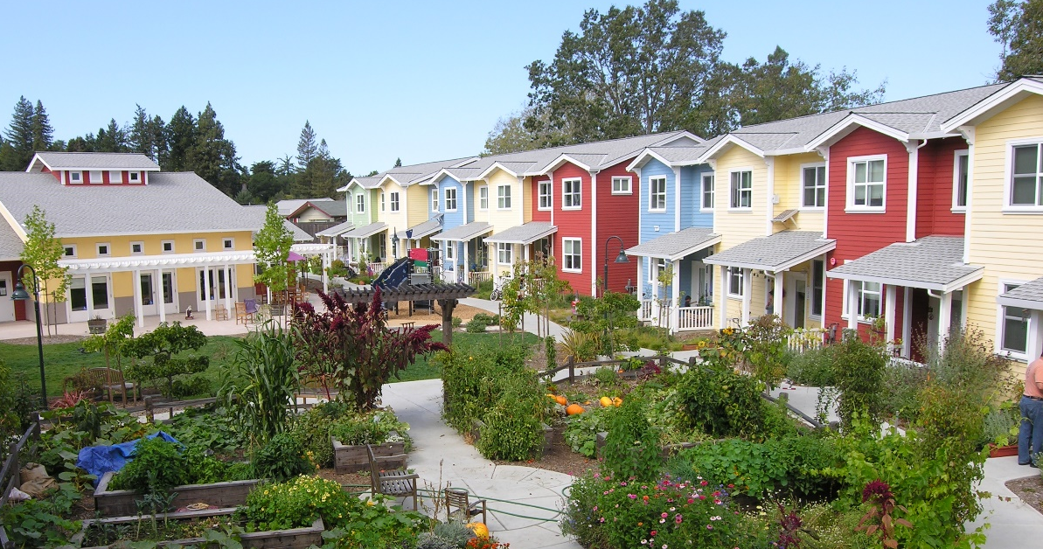

©The Co Housing Association, 2014
Co-housing is a latecomer to the UK. Most of the examples built to date in the UK are new, purpose-built by better-off idealists to be super energy-efficient.
But the UK is full of old, energy-inefficient housing stock. Gwynedd has the oldest.
Frances will introduce the concept of co-housing; and open the question of how it could be applied in existing settlements.
If you are interested in housing justice – environmental footprint – community – Transition, come to the talk and feed in your ideas.

21st November, 6 pm in the Thoday Building, Room G23, Bangor University, Gwynedd.

